1.Program to write the first 10 numbers.

#include <stdio.h>

void main()

{

int i;

printf("The first 10 natural numbers are:\n");

for (i=1;i<=10;i++)

{

printf("%d ",i);

}

printf("\n");

}

Output:



2.Program to calculate the sum of first 10 numbers

n = 10

sum = n * (n+1) / 2

average = ( n * (n+1) / 2) / n

print("Sum of fthe irst ", n, "natural numbers using formula is: ", sum )

print("Average of the first ", n, "natural numbers using formula is: ", average )

3. Make the loop stop when i is 5.

for (i = 0; i < 10; i++) {

if(i=5){

break;

}  
 console.log(i);  
}

4. Write a program to print day of week name using switch case.

#include <stdio.h>

int main()

{

int week;

/* Input week number from user */

printf("Enter week number(1-7): ");

scanf("%d", &week);

switch(week)

{

case 1:

printf("Monday");

break;

case 2:

printf("Tuesday");

break;

case 3:

printf("Wednesday");

break;

case 4:

printf("Thursday");

break;

case 5:

printf("Friday");

break;

case 6:

printf("Saturday");

break;

case 7:

printf("Sunday");

break;

default:

printf("Invalid input! Please enter week number between 1-7.");

}

return 0;

}

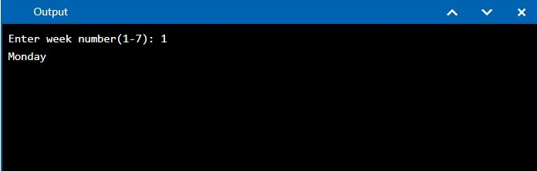

5.Write a program print total number of days in a month using switch case.

**#include <iostream>**

**using** **namespace** std;

**int** main()

{

**int** monthnumber;

//Reading a month number from user

cout<<"Enter month number(1-12): ";

cin>>monthnumber;

**switch**(monthnumber)

{

**case** 1: cout<<"31 days";

**break**;

**case** 2: cout<<"28 or 29 days";

**break**;

**case** 3: cout<<"31 days";

**break**;

**case** 4: cout<<"30 days";

**break**;

**case** 5: cout<<"31 days";

**break**;

**case** 6: cout<<"30 days";

**break**;

**case** 7: cout<<"31 days";

**break**;

**case** 8: cout<<"31 days";

**break**;

**case** 9: cout<<"30 days";

**break**;

**case** 10: cout<<"31 days";

**break**;

**case** 11: cout<<"30 days";

**break**;

**case** 12: cout<<"31 days";

**break**;

**default**: cout<<"Invalid input!!! enter month number between 1-12";

}

**return** 0;

}

